Group name | EUROPEAN TARRIF – LVMNT03-2026-2027-15D14N-THAILAND PASSION | Code | 240926100751
Version | 1 | Sales consultant | sales europe
Group size | 2 - 25 pax(s) | Validity | 01 Jan 2026 – 31 Dec 2027

LVMNT03-2026-2027-15D14N-THAILAND PASSION

LVMNT03-2026-2027-15D14N-PASIÓN POR TAILANDIA

Day 1: Arrival in Bangkok (-)
Arrive at the Bangkok International Airport warmly welcome and proceed to hotel check in (Check in time 14.00)
Overnight in Bangkok.

Día 1: Llegada a Bangkok (-)
Llegada al Aeropuerto Internacional de Bangkok, recepción y traslado al hotel para el check-in (hora de entrada: 14:00).
Noche en Bangkok.

Day 2: Bangkok city (B)
Breakfast at hotel then visit Royal Grand Palace & Emerald Buddha Temple & Reclining Buddha Temple. After that, takes a ferry boat across Chao Phaya River to visit Wat Arun (Temple of Dawn). Afterwards - back to hotel.
Overnight in Bangkok.

Día 2: Bangkok – Recorrido por la ciudad de día completo (D/-/-)
Desayuno en el hotel. Visita al Gran Palacio Real, al Templo del Buda Esmeralda y al Templo del Buda Reclinado. A continuación, cruce en ferry por el río Chao Phraya para visitar Wat Arun (Templo del Amanecer). Regreso al hotel.
Noche en Bangkok

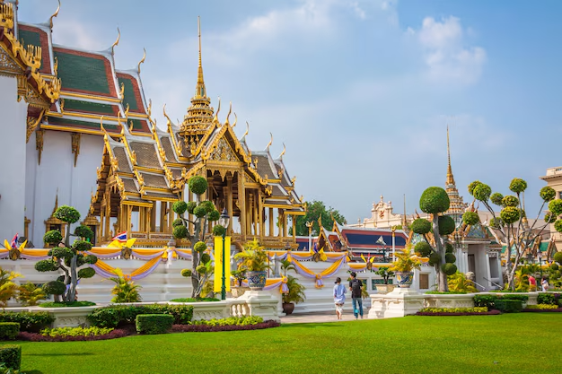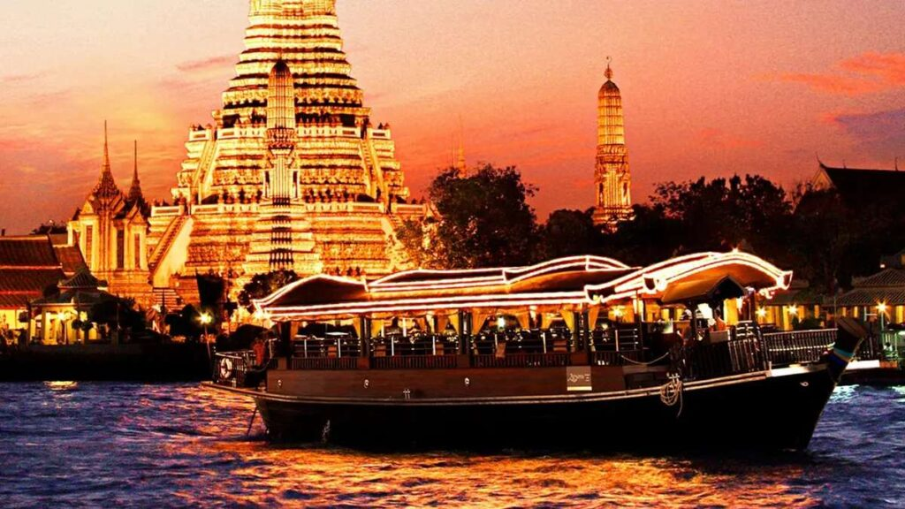
Gran Palacio Real Crucero en río Chao Phraya

Day 3: Bangkok – Mae Klong Raiway market – Damnoen Saduak floating market – Kanchanaburi (B)
Breakfast at hotel and check out. Proceed to visit Damnernsaduak Floating Market
(07:30 - 14:00 hrs.). Drives to the market - on the way visit Salt Farm & Coconut farm - see homemade Sugar from Coconut milk. Take a speed boat ride on small canal to visit the market. Free time to walk around the market. Afterwards visit also Railway Market (Talad Romhub).Continue to Kanchanaburi.
Hotel check in.
Overnight in Kanchanaburi.

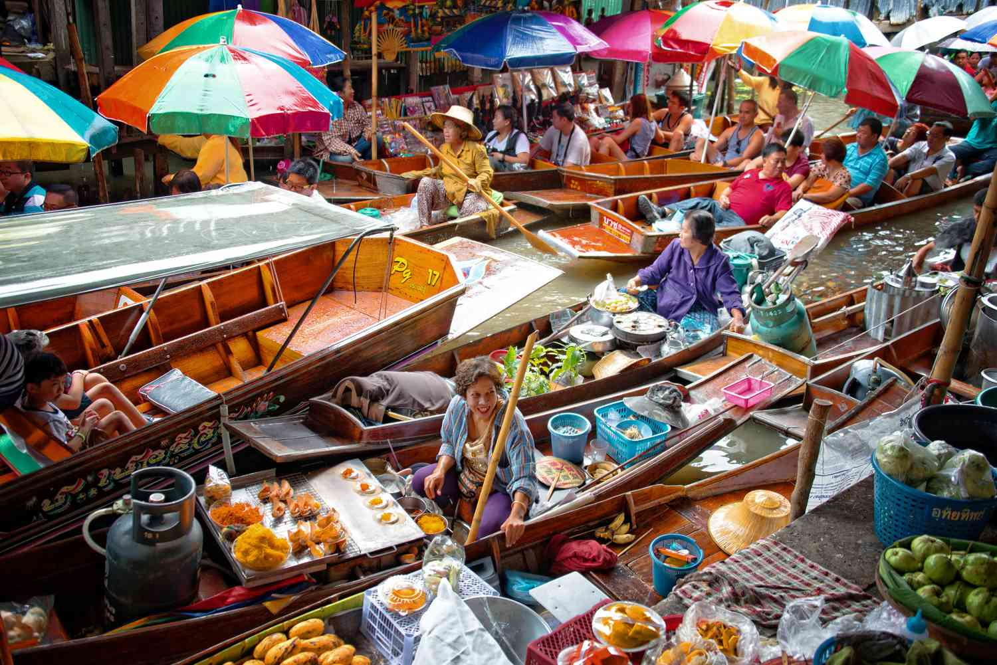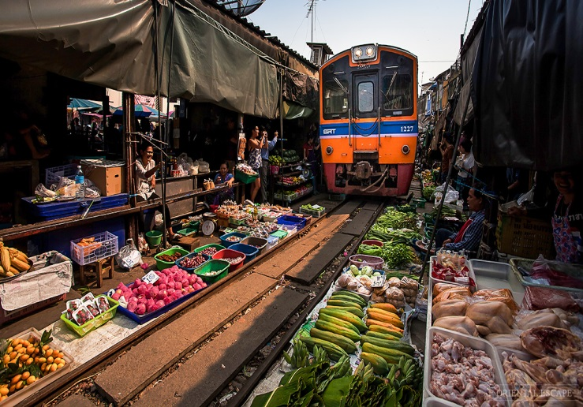
Mercado flotante de Damnernsaduak Mercado ferroviario

Día 3: Bangkok – Mercado ferroviario Mae Klong– Mercado flotante Damnoen Saduak – Kanchanaburi (D)
Desayuno en el hotel. Visita al Mercado Flotante de Damnernsaduak (07:30 – 14:00 hrs). Traslado al mercado; en el camino, visita a una granja de sal y a una granja de cocos, donde se observa la elaboración artesanal de azúcar a partir de la leche de coco. Paseo en lancha rápida por los canales para llegar al mercado. Tiempo libre para recorrerlo.
A continuación, visita al Mercado del Tren (Talad Romhub) y Kanchanaburi.
Noche en Kanchanaburi.

Day 4: Kanchanaburi – Erawan Park – Ayutthaya (B)
Breakfast at hotel and check out. Proceed to visit Kanchanaburi - visit Erawan Waterfall - Located in West Thailand in the Tenasserim Hills range of Kanchanaburi Province, Erawan National Park is home to one of the most popular falls in the country. Proceed to Ayutthaya. Hotel check in.
Overnight in Ayutthaya.
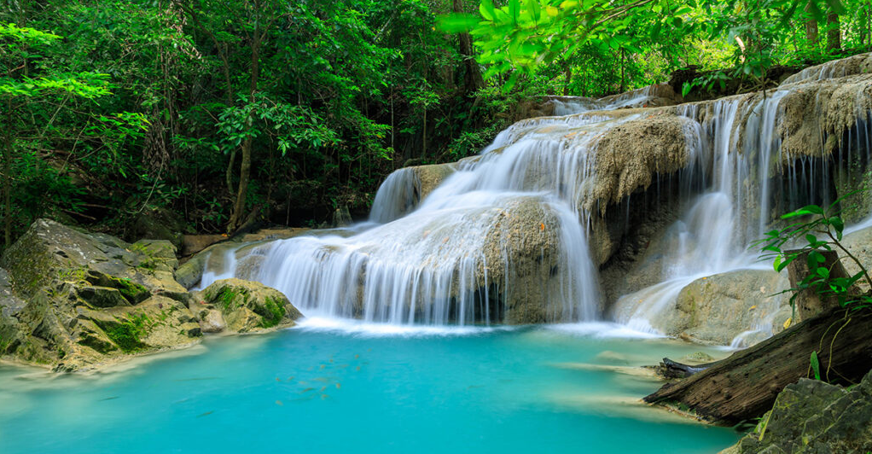
Cascadas de Erawan

Día 4: Kanchanaburi – Cascadas de Erawan – Ayutthaya (D/-/-)
Desayuno en el hotel y check-out. Salida hacia Kanchanaburi para visitar las Cascadas de Erawan, situadas en el oeste de Tailandia, en la cordillera de Tenasserim, dentro del Parque Nacional de Erawan, hogar de una de las cascadas más famosas del país.
Continuación hacia Ayutthaya y check-in en el hotel.
Noche en Ayutthaya.

Day 5: Ayutthaya – Bang Pa-In – Bangkok – Flight to Chiang Rai (B)
Breakfast at hotel. Proceed to visit Bang Pa-In Royal Palace, also known as the Summer Palace, is a palace complex formerly used by the Thai kings. It lies beside the Chao Phraya River in Bang Pa-in District, Phra Nakhon Si Ayutthaya Province in Thailand. Return back to Bangkok. Take flight from Bangkok to Chiang Rai.
Overnight in Chiang Rai.
Suggested Flight: TG 132 BKK CEI 12:25 13:55 (Airfare excluded on our price)

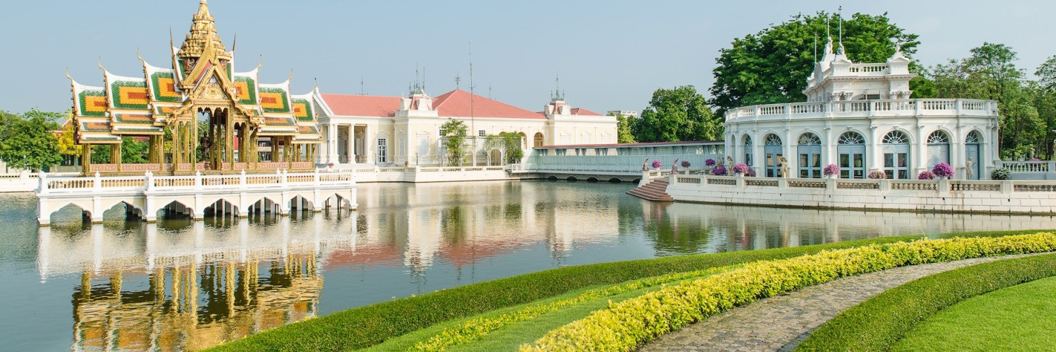
Palacio Real de Bang Pa-In

Día 5: Ayutthaya – Bang Pa-In – Bangkok – Vuelo nocturno a Chiang Mai (D)
Desayuno en el hotel. Visita al Palacio Real de Bang Pa-In, también conocido como el Palacio de Verano, antiguo complejo utilizado por los reyes tailandeses, situado a orillas del río Chao Phraya, en la provincia de Phra Nakhon Si Ayutthaya.
Regreso a Bangkok. Salida en avión desde Bangkok hacia Chiang Mai.
Noche en Chiang Rai.

Day 6: Chiang Rai City (B)
Breakfast at hotel. Enjoy Chiang Rai City Tour - visit Wat Rong khun - white temple. Visit Wat Rong Suea Ten, also known as the Blue Temple, is a temple in Chiang Rai. Continue to visit Mae Sai market.
Overnight in Chiang Rai.
Vuelo sugerido: TG 132 BKK CEI 12:25 13:55 (Tarifa aérea excluida en nuestro precio)

Día 6: Recorrido por Chiang Rai (D)
Desayuno en el hotel. Disfrute del City Tour de Chiang Rai: visita a Wat Rong Khun – Templo Blanco. Visita a Wat Rong Suea Ten, también conocido como el Templo Azul, ubicado en Chiang Rai. Continuación para visitar el mercado de Mae Sai.
Noche en Chiang Rai.

Vuelo sugerido: TG 132 BKK – CEI 12:25 – 13:55 (tarifa aérea excluida en nuestro precio)
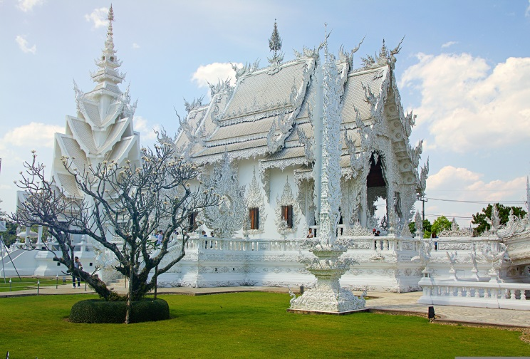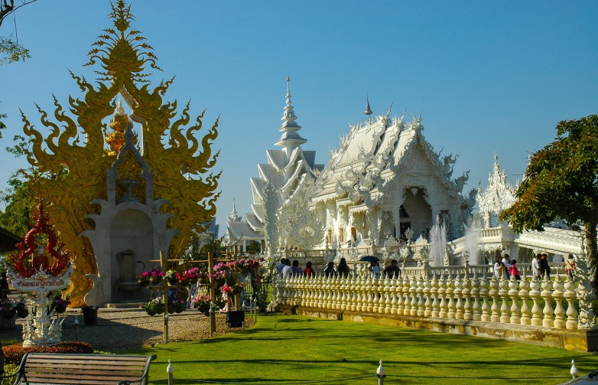
Wat Rong khun – Templo Blanco

Day 7: Chiang Rai – Mae Salong – Golden Triangle – Chiang Saen (B)
Breakfast at hotel. Proceed to visit Doi Mae Salong - Explore the picturesque village of Doi Mae Salong, renowned for tea plantations, Chinese temples and ethnic hill tribe communities. Visit Mae Salong Villa, surrounded by striking mountain and valley vistas.
Overnight in Chiang Saen.

Día 7: Chiang Rai – Mae Salong – Triángulo de Oro – Chiang Saen (D)
Desayuno en el hotel. Salida para visitar Doi Mae Salong: exploración del pintoresco pueblo de Doi Mae Salong, famoso por sus plantaciones de té, templos chinos y comunidades de etnias de las colinas. Visita a Mae Salong Villa, rodeada de impresionantes vistas de montañas y valles.
Noche en Chiang Saen.
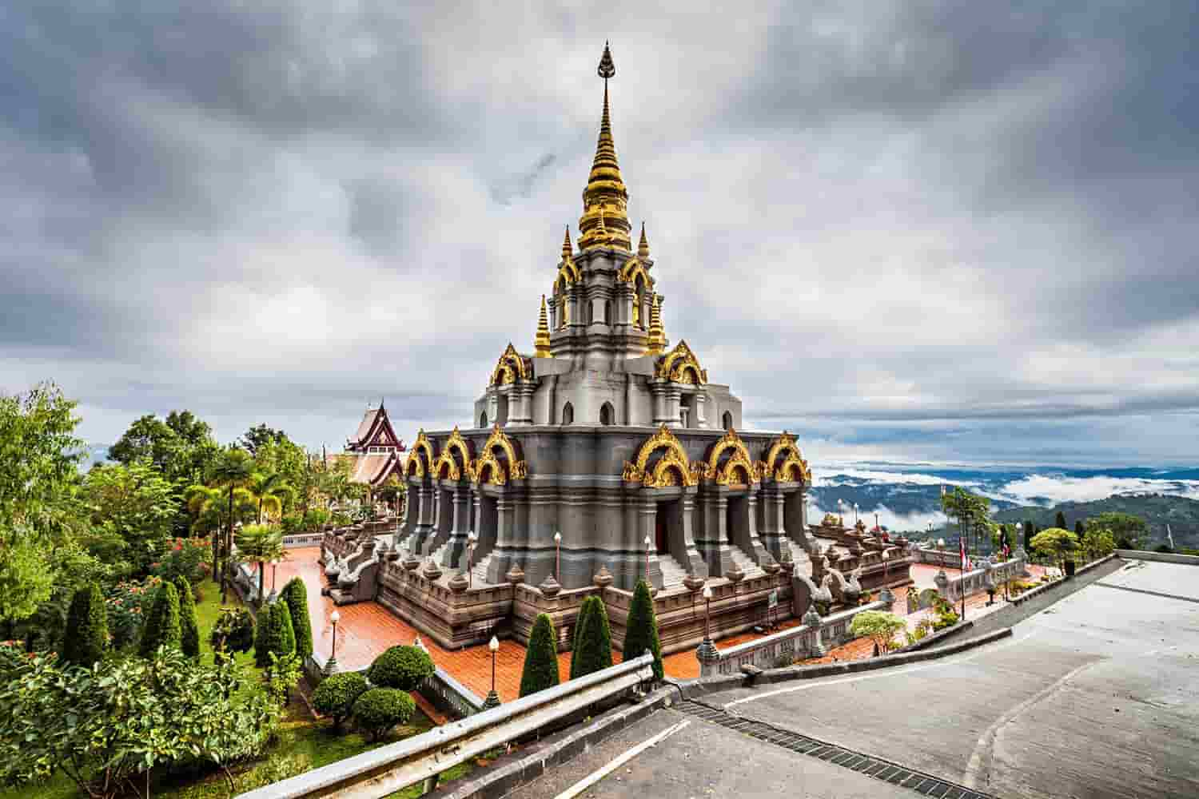
Doi Mae Salong

Day 8: Chiang Saen – Chiang Mai (B)
Breakfast at hotel and check out. Transfer back to Chiang Mai. Hotel check in.
Overnight in Chiang Mai.

Día 8: Chiang Saen – Chiang Mai (D)
Desayuno en el hotel y check-out. Traslado de regreso a Chiang Mai. Check-in en el hotel.
Noche en Chiang Mai.

Day 9: Chiang Mai City & Doi Suthep (B)
Breakfast at hotel. Visit Doi Suthep Temple and Silver Temple. Continue visit to Thapae Old City Gate. Continue visit to Wat Chedilung Temple.
Overnight in Chiang Mai.

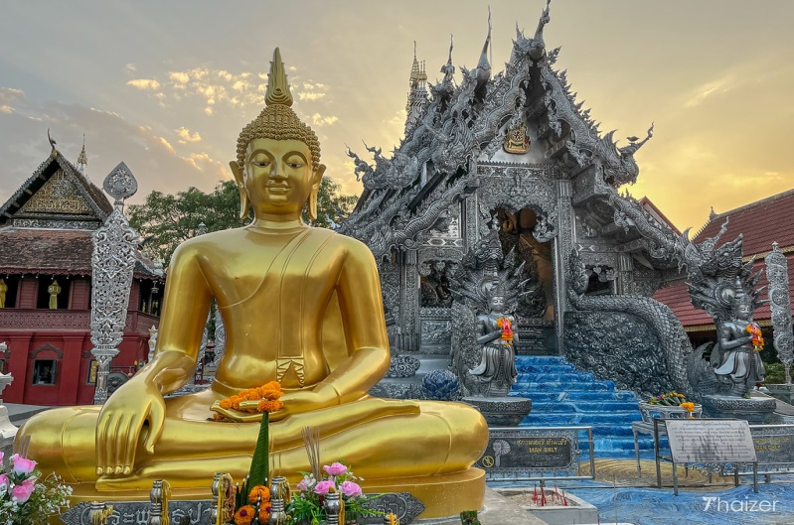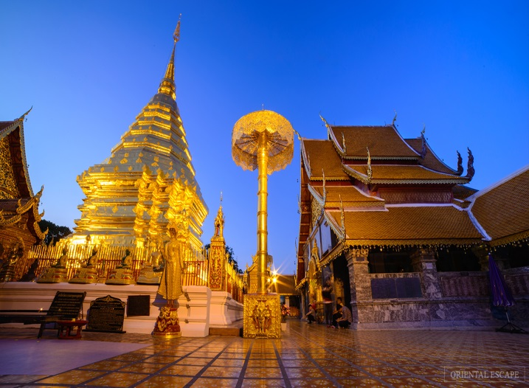
Templo de Plata Templo de Doi Suthep

Día 9: Ciudad de Chiang Mai y Doi Suthep (D)
Desayuno en el hotel. Visita al Templo de Doi Suthep y al Templo de Plata. Continuación para visitar la Puerta de la Ciudad Antigua Thapae. Continuación para visitar el Templo de Wat Chedilung.
Noche en Chiang Mai

Day 10: Chiang Mai – Elephant Poopoo paper & Mae Ping river cruise – Night train to Bangkok (B,L)
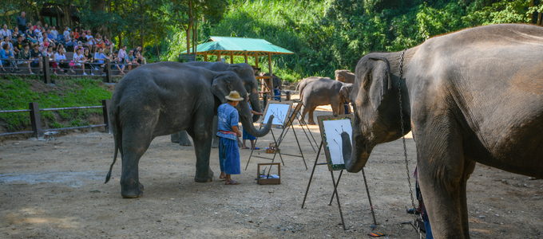
Elephant Poopoo Paper Park

Breakfast at hotel. Head to Elephant Poopoo Paper Park, a unique and eco-friendly attraction where you will discover the fascinating process of making paper products from elephant waste. Enjoy for Mae Ping River Cruise - Leave from the jetty at Wat Chai Mongkol and travel north out of the city. The river soon shows its true rural identity as city bridges pass from view and are replaced by scenes of wide water stretching from green tree lined bank to bank , Kids play, daring each other to swing through an old motor Tyre and plunge into the cool river below, Smiles ,Yells. And the boat chugs on to reach its destination point the “Thai Farmer’s House”. Agriculture remains Thailand’s largest source of income and here the visitor can discover the basic elements-rice, local herbs, fruits, fishing-all thriving in a chemical-free environment. Lunch at restaurant. At night take a overnight train from Chiang Mai to Bangkok.
Overnight on Train.

Día 10: Chiang Mai – Elephant Poopoo Paper & Crucero por el río Mae Ping – Tren nocturno a Bangkok (D, A)
Desayuno en el hotel. Salida hacia Elephant Poopoo Paper Park, una atracción única y ecológica donde descubrirá el fascinante proceso de elaboración de productos de papel a partir de desechos de elefante.
Disfrute de un crucero por el río Mae Ping: salida desde el embarcadero de Wat Chai Mongkol y navegación hacia el norte fuera de la ciudad. El río pronto muestra su auténtica identidad rural, ya que los puentes urbanos quedan fuera de vista y son reemplazados por escenas de amplias aguas flanqueadas por orillas verdes. Niños juegan, se desafían unos a otros para balancearse desde un neumático viejo y lanzarse al fresco río, entre sonrisas y gritos. La embarcación continúa hasta llegar a su destino, la “Casa del Agricultor Tailandés”. La agricultura sigue siendo la principal fuente de ingresos de Tailandia y aquí el visitante puede descubrir los elementos básicos —arroz, hierbas locales, frutas y pesca— todos prosperando en un entorno libre de químicos.
Almuerzo en restaurante. Por la noche, toma del tren nocturno desde Chiang Mai a Bangkok.
Noche en el tren.

Day 11: Bangkok – transfer to Trat – Koh Chang Island (-)
Upon arrival at Bangkok Train Station, warmly welcome by tour guide and proceed to trat. Take ferry boat and hotel check in.
Overnight in Koh Chang.

Día 11: Bangkok – Traslado a Trat – Isla de Koh Chang (-)
A su llegada a la estación de tren de Bangkok, recibirá una cálida bienvenida por parte del guía turístico y se dirigirá a Trat. Embarque en el ferry y registro en el hotel.
Noche en Koh Chang.
Day 12: Koh Chang Island free & easy (B) No guide no driver
Breakfast at hotel. Free and easy.
Overnight in Koh Chang.

Día 12: Isla de Koh Chang, libre y tranquilo (D) - Sin guía ni conductor
Desayuno en el hotel. Día libre.
Noche en Koh Chang.

Day 13: Koh Chang Island free & easy (B) No guide no driver
Breakfast at hotel. Free and easy.
Overnight in Koh Chang.

Día 13: Isla de Koh Chang (D) - Sin guía ni conductor
Desayuno en el hotel. Tiempo libre.
Noche en Koh Chang.

Day 14: Koh Chang – Trat – transfer to Bangkok (B)
Breakfast at hotel and check out. Take ferry boat and meet with guide. Proceed back to Bangkok. Hotel check in.
Overnight in Bangkok.

Día 14: Koh Chang – Trat – Traslado a Bangkok (D)
Desayuno en el hotel y salida del hotel. Embarque en el ferry y encuentro con el guía. Regreso a Bangkok. Registro en el hotel.
Noche en Bangkok.

Day 15: Bangkok departure (B)
Breakfast at hotel and check out. Proceed to Bangkok Airport for your flight to home.

End of services!

Día 15: Salida de Bangkok (D)
Desayuno en el hotel y salida del hotel. Salida al aeropuerto de Bangkok para tomar su vuelo de regreso.
Fin de servicios
List of accommodations
Lista de alojamientos

No | City  Ciudad | Category  Categoría | HOTEL or similar  Hotel o similar
1 | Bangkok | 4* | Montien riverside (or) Similar - ROH
2 | Bangkok | 5* | Chatrium Riverside (or) Similar- ROH
3 | Kanchanaburi | 4* | U Inchantree Kanchanaburi (or) Similar - ROH
4 | Kanchanaburi | 5* | Dheva Mantra Resort (or) Similar- ROH
5 | Ayutthaya | 4* | Centara Ayutthaya (or) Similar - ROH
6 | Ayutthaya | 5* | Sala Ayutthaya (or) Similar - ROH
7 | Chiang Rai | 4* | The Legend Chiang Rai (or) Similar - ROH
8 | Chiang Rai | 5* | The Heritage (or) Similar- ROH
9 | Chiang Saen | 4* | Siam Triangle Hotel (or) Similar - ROH
10 | Chiang Mai | 4* | The Empress Chiang Mai (or) Similar - ROH
11 | Chiang Mai | 5* | Shangrila Chiang Mai (or) Similar - ROH
12 | Koh Chang | 4* | Awa Resort Koh Chang (or) Similar - ROH

Rates and Conditions
Prices are in USD per person, based on two guests sharing a twin or double room in the hotels mentioned above.

Tarifas y condiciones
Los precios están expresados en dólares estadounidenses por persona, en base a dos huéspedes compartiendo habitación doble o twin en los hoteles mencionados.

Surcharge for peak season or festival if any (upon booking) within following periods: 2026-2027
- New Year / PEAK SEASON Period: 20th December 2026 – 10th January 2026/2027
- Songkran Water Festival: 12th – 15th April 2026/2027
- Golden Week: 26 Apr - 5 May 2026/2027
1st - 7th October 2026 /2027
- Loykrathong Festival:
23 – 28 November 2026
14 - 19 November 2027

Recargo por temporada alta o festival (si lo hubiera) (al reservar) en los siguientes períodos: 2026-2027
- Año Nuevo / TEMPORADA ALTA: 20 de diciembre de 2026 - 10 de enero de 2026/2027
- Festival del Agua Songkran: 12 - 15 de abril de 2026/2027
- Semana Dorada: 26 de abril - 5 de mayo de 2026/2027
1 - 7 de octubre de 2026/2027
- Festival Loykrathong: 23 - 28 de noviembre de 2026
14 - 19 de noviembre de 2027
01 Jan 2026 – 30 Apr 2026 & 01 Oct 2026 – 31 Oct 2026

01 de enero de 2026 – 30 de abril de 2026 y 01 de octubre de 2026 – 31 de diciembre de 2026
Group size/ | 2 | 3 | 4 | 05-07 | 08-09 | 10-15 | 16-20 | 21-25 | SGL Plus
Transfer Type | 4 Seats Car | 9 Seats Van | 9 Seats Van | 9 Seats Van | 20 Seats Bus | 20 Seats Bus | 30 Seats Bus | 30 Seats Bus | SGL Plus
Price per person in USD | NO FOC |  |  |  |  |  | 1 FOC in twin |  | SGL Plus
4* | 4,580 | 3,599 | 3,108 | 2,871 | 2,819 | 2,595 | 2,377 | 2,191 | 1,077
5* | 5,491 | 4,519 | 4,034 | 3,798 | 3,765 | 3,544 | 3,372 | 3,173 | 2,000
01 May 2026 -30 Sept 2026

1 de mayo de 2026-30 de septiembre de 2026
Group size/ | 2 | 3 | 4 | 05-07 | 08-09 | 10-15 | 16-20 | 21-25 | SGL Plus
Transfer Type | 4 Seats Car | 9 Seats Van | 9 Seats Van | 9 Seats Van | 20 Seats Bus | 20 Seats Bus | 30 Seats Bus | 30 Seats Bus | SGL Plus
Price per person in USD | NO FOC |  |  |  |  |  | 1 FOC in twin |  | SGL Plus
4* | 4,491 | 3,510 | 3,019 | 2,781 | 2,731 | 2,507 | 2,288 | 2,103 | 994
5* | 5,388 | 4,417 | 3,931 | 3,695 | 3,656 | 3,435 | 3,270 | 3,070 | 1,902
01 Jan 2027 – 30 Apr 2027 & 01 Oct 2027 – 31 Oct 2027

01 de enero de 2027 – 30 de abril de 2027 y 01 de octubre de 2027 – 31 de diciembre de 2027
Group size/ | 2 | 3 | 4 | 05-07 | 08-09 | 10-15 | 16-20 | 21-25 | SGL Plus
Transfer Type | 4 Seats Car | 9 Seats Van | 9 Seats Van | 9 Seats Van | 20 Seats Bus | 20 Seats Bus | 30 Seats Bus | 30 Seats Bus | SGL Plus
Price per person in USD | NO FOC |  |  |  |  |  | 1 FOC in twin |  | SGL Plus
4* | 4,808 | 3,778 | 3,263 | 3,014 | 2,960 | 2,724 | 2,496 | 2,301 | 1,128
5* | 5,765 | 4,745 | 4,235 | 3,987 | 3,952 | 3,719 | 3,541 | 3,332 | 2,097
01 May 2027 -30 Sept 2027

01 de mayo de 2027-30 de septiembre de 2027
Group size/ | 2 | 3 | 4 | 05-07 | 08-09 | 10-15 | 16-20 | 21-25 | SGL Plus
Transfer Type | 4 Seats Car | 9 Seats Van | 9 Seats Van | 9 Seats Van | 20 Seats Bus | 20 Seats Bus | 30 Seats Bus | 30 Seats Bus | SGL Plus
Price per person in USD | NO FOC |  |  |  |  |  | 1 FOC in twin |  | SGL Plus
4* | 4,714 | 3,685 | 3,170 | 2,920 | 2,867 | 2,632 | 2,402 | 2,208 | 1,041
5* | 5,657 | 4,637 | 4,127 | 3,880 | 3,838 | 3,605 | 3,433 | 3,224 | 1,994

Our package includes
14 Nights accommodation as stated in the itinerary with daily breakfast (based on twin/double sharing)
Private Transfer Service
Private Tour With English Speaking Guide include transfer
Private airport arrival & departure transfer service
Admission fees, with instruction where necessary

Nuestro paquete incluye:
8 noches de alojamiento según el itinerario con desayuno diario (en base a habitación doble o twin).
Servicio de traslado privado.
Tour privado con guía de habla inglesa (incluye traslado).
Servicio de traslado privado desde y hasta el aeropuerto.
Entradas, con instrucciones si es necesario.

Our package excludes
- Flight ticket Bangkok – Chiang Rai
-Visa stamps upon arrival of $30.00 / pax
-Meals not indicated
-Tips & gratuities
-personal expenses
-Laundry
-Other not stated above
-Travel insurance
• TIPPING for local guide and van driver
* 1 pax: 15 USD/ pax/ day
* 2 - 4 pax: 10 USD/ pax/ day
* 5 pax: 6 USD/ pax/ day
*Suggested TIPPING for bellboy, boat crew, sampan driver: depend on your satisfied
Nuestro paquete no incluye:
- Billetes de avión Bangkok – Phuket
- Visado a la llegada: 30,00 USD por persona.
- Comidas no indicadas en el programa.
- Propinas y gratificaciones
- Gastos personales.
- Lavandería.
- Otros servicios no mencionados anteriormente.
- Seguro de viaje.
- PROPINA para guía local y conductor:
* 1 pax: 15 USD / pax / día
* 2 – 4 pax: 10 USD / pax / día
* 5 pax: 6 USD / pax / día
* Propina sugerida para botones, tripulación del barco y remeros de sampán: según el grado de satisfacción del cliente.

GENERAL TERMS & CONDITIONS
Remarks for check in and check out schedules
Check in time: at hotel: after 14h00 – on cruise: before 12h00.
Check out time: at hotel & on cruise: before 12h00.
Remarks for itinerary
The itinerary and schedule are subject to change due to local traffic situations, weather conditions; flight, or any un-foreseen circumstances or local authority decision. LV Travel reserves full rights to replace all items with same values for guests.
Remarks for meal
Meals are fusion on local food with daily normal buffet breakfast at hotel. Guests should advise any special food preferences, allergies or dietary requirements at least one (1) week prior to the arrival date.
Remarks for the price
16 full paying pax group is granted one FOC based on half twin (exclusive of extra service).
Please be aware that any changes in the itinerary due to unforeseen circumstances might result in increase in pricing.
Any damage caused to all services during the stay shall be payable by the passengers.
Validity
All prices quoted to the Client/Agent are on a net basis in United States Dollars and valid according to the date specified on the LV Travel printed tariffs and/or quotation and/or invoice issued to the Client/Agent. LV Travel warrants that the prices or rates quoted to the Client/Agent are correct at the time of issuance or invoice but are subject to change in line with market, tax or currency fluctuation, with or without prior notice.
Payment method
Unless otherwise agreed by LV Travel, client’s payment shall be executed by bank transfer, to the LV travel’s bank account clearly noted in all the invoices. Every party shall take care of the transfer fees occurring with its relevant bank.
Payment conditions for domestic or international flights : We will check case by case.
Payment conditions for land tour without flights:
- In general there is no Deposit required. LV Travel reserves its right to forward deposit requests from suppliers in case they occur.
- The full payment of 100% of the total price must be transferred to the LV Travel account 30 days prior to the group arrival in Indochina, if not agreed otherwise.
Cancellation of domestic or international flights: We will check case by case.
Cancellation policy for land tour without flights:
- All cancellations should be made in writing and should be acknowledged by LV travel.
-Cancellation Rules for Land Tour, not apply for domestic or international flights (if any).
- Cancellation more than 30 days prior to the group arrival: No Charge. Deposit shall be deducted into the next bookings, except specified suppliers require cancellation fees.
- Cancellation between the 30th and 21st day prior to the group arrival: 30% of the total tour price.
- Cancellation between the 20th and 14th day prior to the group arrival: 50% of the total tour price.
- Cancellation between the 13th and 07th day prior to the group arrival: 75% of the total tour price.
- Cancellation between the 06th and 03rd day prior to the group arrival: 80% of the total tour price.
- Cancellation between the 02nd and 0 day prior to the group arrival: 100% of the total tour price.
- In case the tour participant(s) shorten or interrupt the tour of their own accord there will be no reimbursements.
- Reduction in the number of passengers against requested bookings is considered and treated as cancellations.
- If the balance of the tour invoice is not received by the deadline of 15days prior to the group arrival, LV Travel will reserve the right to cancel the reservation without indemnity or any reimbursement.
- If LV Travel is forced to cancel the departure due to unforeseeable reasons, the participants will be fully reimbursed without intention to claim for any indemnities.

Contact details
Hotline for sales (ms Moon) | +84 888 905 286 (WA/viber/mobile)
Hotline for operation (ms Anna Hanh) | +84 983 096 032(WA/viber/mobile)
General Manager Mr Len | +84 989 200 116 (WA/viber/mobile)

TÉRMINOS Y CONDICIONES GENERALES

Información sobre los horarios de entrada y salida
Hora de entrada: en el hotel: después de las 14:00 h - en el crucero: antes de las 12:00 h.
Hora de salida: en el hotel y en el crucero: antes de las 12:00 h.

Información sobre el itinerario
El itinerario y el horario están sujetos a cambios debido a la situación del tráfico local, las condiciones meteorológicas, el vuelo, cualquier circunstancia imprevista o decisión de las autoridades locales. LV Travel se reserva el derecho de reemplazar todos los artículos por el mismo precio para los huéspedes.

Información sobre las comidas
Las comidas son una fusión de platos locales con desayuno buffet diario en el hotel. Los huéspedes deben informar sobre cualquier preferencia alimentaria, alergia o requisito dietético especial con al menos una (1) semana de antelación a la fecha de llegada.

Información sobre el precio
A los grupos de 16 personas que pagan la tarifa completa se les otorga una habitación compartida (sin incluir servicios adicionales).
Tenga en cuenta que cualquier cambio en el itinerario debido a circunstancias imprevistas podría resultar en un aumento de precios.
Cualquier daño causado a los servicios durante la estancia será responsabilidad de los pasajeros.

Validez
Todos los precios cotizados al Cliente/Agente son netos en dólares estadounidenses y válidos según la fecha especificada en las tarifas impresas de LV Travel, la cotización o la factura emitida al Cliente/Agente. LV Travel garantiza que los precios o tarifas cotizadas al Cliente/Agente son correctos al momento de la emisión de la factura, pero están sujetos a cambios según las fluctuaciones del mercado, los impuestos o la moneda, con o sin previo aviso.

Método de pago
Salvo acuerdo en contrario con LV Travel, el pago del cliente se realizará mediante transferencia bancaria a la cuenta bancaria de LV Travel claramente indicada en todas las facturas. Cada parte se hará cargo de los gastos de transferencia con su banco correspondiente.

Condiciones de pago para vuelos nacionales o internacionales: Se revisará cada caso individualmente.
Condiciones de pago para tours terrestres sin vuelos:
- Generalmente, no se requiere depósito. LV Travel se reserva el derecho de reenviar las solicitudes de
depósito de los proveedores en caso de que se produzcan.
- El pago completo del 100% del precio total debe transferirse a la cuenta de LV Travel 30 días antes de la llegada del grupo a Indochina, salvo acuerdo en contrario.
Cancelación de vuelos nacionales o internacionales: Se revisará cada caso individualmente.
Política de cancelación para tours terrestres sin vuelos
- Todas las cancelaciones deben realizarse por escrito y LV Travel debe confirmar su recepción.
- Las normas de cancelación para tours terrestres no aplican para vuelos nacionales o internacionales (si los hubiera).
- Cancelación con más de 45 días de antelación a la llegada del grupo: Sin cargo. El depósito se descontará de las siguientes reservas, excepto en el caso de proveedores específicos que requieran cargos por cancelación.
- Cancelación entre el 45 y el 31 días antes de la llegada del grupo: 25% del precio total del tour.
- Cancelación entre el 30 y el 23 días antes de la llegada del grupo: 30% del precio total del tour.
- Cancelación entre el 22 y el 16 días antes de la llegada del grupo: 40% del precio total del tour.
- Cancelación entre el 15 y el 9 días antes de la llegada del grupo: 60% del precio total del tour.
- Cancelación entre el 8 y el 3 días antes de la llegada del grupo: 80% del precio total del tour.
- Cancelación entre el 2 y el 0 días antes de la llegada del grupo: 100% del precio total del tour.

- En caso de que el/los participante(s) del tour acorten o interrumpan el tour por decisión propia, no se realizarán reembolsos. - La reducción del número de pasajeros respecto a las reservas solicitadas se considera una cancelación.
- Si el saldo de la factura del tour no se recibe dentro de los 15 días previos a la llegada del grupo, LV Travel se reserva el derecho de cancelar la reserva sin indemnización ni reembolso alguno.
- Si LV Travel se ve obligado a cancelar la salida por causas imprevistas, los participantes recibirán un reembolso completo sin derecho a reclamar indemnización alguna.

Contacto detallado
Línea directa de ventas (Sra. Moon) | +84 888 905 286 (WA/Viber/móvil)
Línea directa de operaciones (Sra. Anna Hanh) | +84 983 096 032(WA/viber/ móvil)
Gerente general, Sr. Len | +84 989 200 116 (WA/viber/ móvil)

